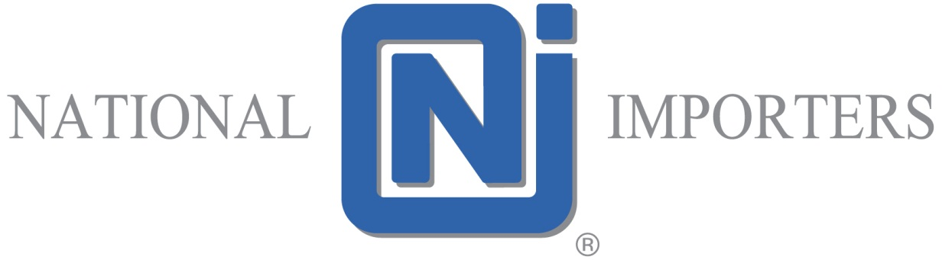
120-13100 Mitchell Road
Richmond BC V6V 1M8
604-324-1551

JOB DESCRIPTION

MANAGER OF QUALITY ASSURANCE and REGULATORY AFFAIRS

General:
Reporting to the Director of Operations, the individual is responsible for developing and managing CFIA and FDA food safety programs (HACCP, GMP and GIP Programs) suitable for National Importers operations in Canada and the United States. The successful candidate must have extensive knowledge of the Canadian Food and Drugs Act, Safe Foods for Canadians Act and the United States Food Safety Modernization Act. The individual will have suitable experience and recognized qualifications in HACCP, GFSI, GMP and/or GIP Programs. The individual must have a minimum of five years of experience in developing and managing food safety compliance programs including managing a food safety team. The candidate must be proficient in MS Word and Excel. Good listening, verbal and written communication skills are essential in this leadership role. The successful candidate should have experience working within a rapidly changing and dynamic company.
Duties and Responsibilities:
The following list of duties and responsibilities of this position is not intended to be an all-inclusive list of duties and responsibilities of the job described. Rather they are intended only to describe the general nature of the job.
- Managing the QA Department – hiring, assessing, goal setting, training, praising, and termination of staff. Hiring and termination require the involvement and prior authorization of Human Resources and the Director of Operations
- Preparing the budget, which will include lab testing and training of staff
- Developing, implementing and maintaining HACCP Plans and related food safety policies and procedures appropriate for National Importers
- Staying abreast of industry and market trends from a food safety perspective
- Conducting audits on suppliers and storage facilities as needed

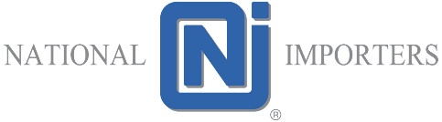

JOB DESCRIPTION

MANAGER OF QUALITY ASSURANCE and REGULATORY AFFAIRS
Duties and Responsibilities continued…
- Auditing and enforcing company compliance with all aspects of the HACCP Programs. This includes compliance with the Prerequisite Programs, Supplier Letters of Guarantee, QA Manual of Procedures and any other relevant programs which impact the integrity of the HACCP Program and food safety
- Organizing and leading HACCP meetings, producing and distributing the minutes of these meetings and following up on corrective actions when required
- Identifying and resolving HACCP non-compliance issues in a timely manner
- Organizing and conducting HACCP, GMP/GIP and sanitation training for plant employees
- Conducting HACCP training for new employees
- Coordinating mock recalls as well as playing a lead role in corporate recalls for the Canadian and the US operations
- Playing a major role in CFIA and customer HACCP and/or food safety & GMP/GIP audits, and then either leading or participating in teams to implement corrective actions when deviations are found
- Staying current on Canadian and United States food safety regulations and other related compliance programs by attending and participating in CFIA and third-party information meetings and training programs at NI expense
- Overseeing customer/consumer complaint programs and submitting monthly reports to senior management

- Managing the product labelling program

- Providing brand product support including core labelling elements, permitted ingredients, additives, preservatives, licenses and product inquiries for such items as fish and processed products

- Ensuring NI compliance with customer food safety programs

- Maintaining the necessary technical skills and knowledge through reading, networking and training

JOB DESCRIPTION

MANAGER OF QUALITY ASSURANCE and REGULATORY AFFAIRS

Qualifications Required:
- Bachelor degree or diploma in food science or related field from a recognized Canadian institution
- Recognized qualifications and demonstrated experience in HACCP, GFSI, GMP and/or GIP programs
- Experience in the regulatory and food safety aspects of consumer packaged goods and/or the food service industries would be an asset
- Five years of experience with demonstrated competence in developing, implementing and overseeing quality assurance and food safety programs
- Two years of experience at the Manager or Director level overseeing the food safety programs and a food safety/quality assurance team
- Experience working with CFIA, third party and blue-chip customer auditors
- Proficient with Microsoft Excel and Word
- Flexible with working hours
- Works under minimal supervision
- Works well in team environments
- Strong organizational, verbal and written communication skills
- Ability to lead with confidence
- Detail oriented

JOB DESCRIPTION

MANAGER OF QUALITY ASSURANCE and REGULATORY AFFAIRS
Other suggestions:
1. Impact & Accountabilities:
> Corporate culture characteristics of:
- Respect, teamwork and innovation.
- Requires knowledge of many confidential matters to work in strict confidence.
> Working towards success of the organization in relation to:
- The regulatory licenses, the quality of the products and the services offered can be adversely impacted by the improper development and
- Maintenance of HACCP programs and operations manuals.
2. Physical Effort: Computer work.
3. Travel: Some travel will be required

